**Value of Properties Owned (Database)**

QUESTION DESCRIPTION

There are two tables in a database of real estate owners. One has ownership information and the other has price information, in millions. An owner may own multiple houses, but a house will have only one owner.

Write a query to print the IDs of the owners who have at least 100 million worth of houses and own more than 1 house. The order of output does not matter. The result should be in the format: BUYER_ID TOTAL_WORTH

Schema

There are 2 tables: house , price .

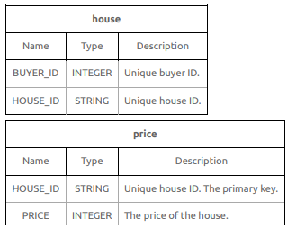

Sample Data Tables

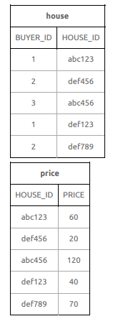

**Sample Output**

1 100

Explanation

* 1 has a total of (60 + 40) = 100 million worth houses and is included in the results.
* 3 has a total of 120 million worth houses but has only 1 house.
* 2 has a total of (20 + 70) = 90 million worth of houses.

CANDIDATE ANSWER

Language used: MySQL

/*

Enter your query below.

Please append a semicolon ";" at the end of the query

*/

**Solution**

select house.buyer_id ,sum(price.price) from house,price where house.house_id = price.house_id group by house.buyer_id having sum(price.price)>=100 and count(house.house_id) >1;